# Networking Lab 5 Routing Protocols

## Routing Tables

When a router is forwarding a packet, it first looks to see if it is directly connected (C in the router’s table) to the destination network. In that case, the decision is easy, and the router sends the packet using the interface that connects to the destination network. When there are multiple routers the decision is more difficult, and the router needs a table to tell it where to send the packet.

In our last lab with routers, each half of the classroom had its own router and networks. Since there was only one router, it had a direct connection to each network and the routing decisions were simple  
.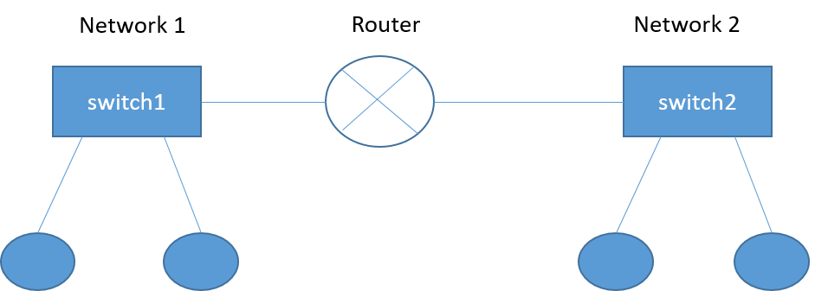

Now, we are going to add a router that connects the two halves of the classroom so there will be three routers. Unless we find a way to teach each router where the other routers and networks are, there will be networks that cannot communicate with each other. For example, a host on Network 1 will not be able to communicate with Networks 3 and 4, because Router A does not have a direct connection to them. We will have to find a way to tell Router A about Networks 3 and 4. Likewise, Router C needs to find Networks 1 and 2; Router B needs to find Networks 1 and 3.

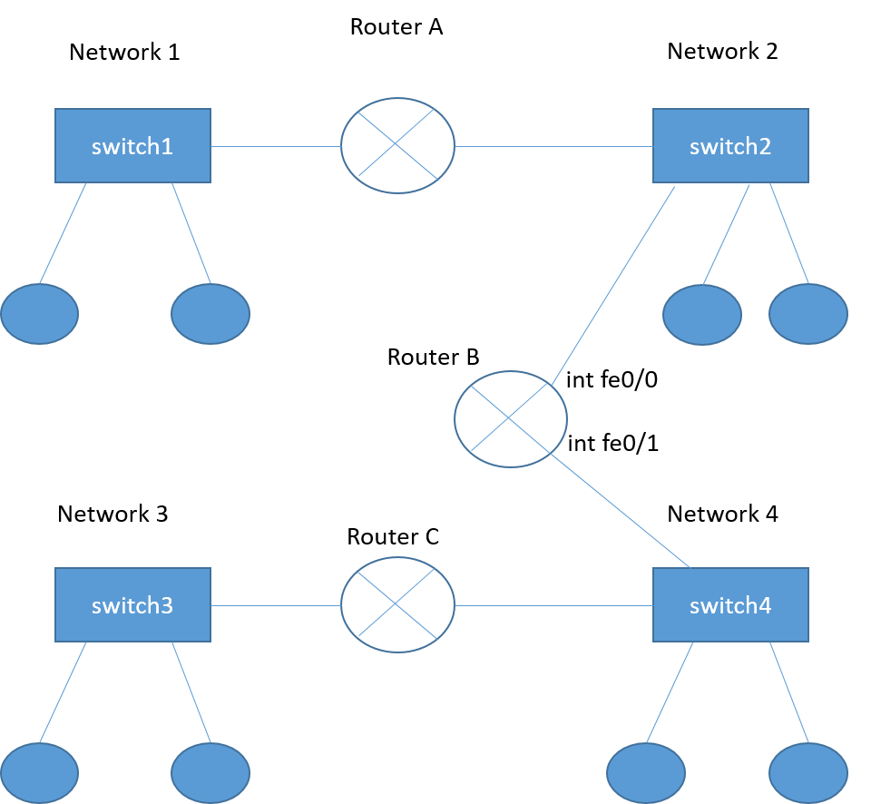

## Default Routes

A default route (also called gateway of last resort) is similar to a default gateway on a host (computer). It tells the router, “If you don’t know where to send a packet, send it here.” Default routes will be all we need for Routers A and C. If Router A sends packets for unknown networks to Router B, that will work for traffic to Network 4 and Network 3. If Router C sends traffic for unknown networks to Router B, that will work for both Networks 1 and 2.

Routers use 0.0.0.0 to mean “any”, both for IP addresses and subnet masks. To enter a default route in Router A, we would use this command:

*ip route 0.0.0.0 0.0.0.0 [ip address of Router B interface fe0/0]*

This tells the router that traffic to any IP address, with any subnet mask, should be sent to the closest interface on Router B. Since directly Connected routes have the highest priority, traffic bound for Networks 1 and 2 will be sent directly to the hosts using Router A’s interfaces. Traffic for Networks 3 and 4 will be sent to Router B.

This is a sample command to enter a default route, and a sample routing table for Router A or C. Note that the network addresses will be different in your lab.

Router#conf t

Enter configuration commands, one per line. End with CNTL/Z.

Router(config)#ip route 0.0.0.0 0.0.0.0 192.168.2.2

Router(config)#^Z

Router#

*Aug 29 13:25:35.240: %SYS-5-CONFIG_I: Configured from console by console

Router#show ip route

Codes: C - connected, S - static, R - RIP, M - mobile, B - BGP

D - EIGRP, EX - EIGRP external, O - OSPF, IA - OSPF inter area

N1 - OSPF NSSA external type 1, N2 - OSPF NSSA external type 2

E1 - OSPF external type 1, E2 - OSPF external type 2

i - IS-IS, su - IS-IS summary, L1 - IS-IS level-1, L2 - IS-IS level-2

ia - IS-IS inter area, * - candidate default, U - per-user static route

o - ODR, P - periodic downloaded static route

Gateway of last resort is 192.168.2.2 to network 0.0.0.0

C 192.168.1.0/24 is directly connected, FastEthernet0/0

C 192.168.2.0/24 is directly connected, FastEthernet0/1

S* 0.0.0.0/0 [1/0] via 192.168.2.2

Router#

You can see from the routing table that interface FastEthernet0/0 is connected to the 192.168.2.0/24 network (remember that /24 is CIDR shorthand for 255.255.255.0), and interface FastEthernet0/1 is connected to the 192.168.1.0/24 network. The routers send any other traffic using the static route (S) to 192.168.2.2. In this case, 192.168.2.2 had better be the nearest interface on Router B.

## Static Routes

We have configured Routers A and C so they know where to send traffic. However, we still have a problem with Router B. Routers A and C know to send traffic to each other to Router B, but Router B does not know what to do with it. A simple default route will not work, since Router B has multiple networks connected to both interfaces.

The command for a static route is very similar to that for a default route. Instead of listing the destination network as 0.0.0.0 0.0.0.0 (i.e., anything, or wild card) we use the destination network address. The static route tells the router the address for the next hop along the path to reach the destination.

See the diagram below for addresses in this example. The 192.168.1.0/24 network is connected to interface fe0/0 of Router A. Router B needs to know that the next hop to that network is the fe0/1 interface of Router A. In our example, the IP address on fe0/0 is 192.168.2.1. Once Router A receives the traffic on its fe0/1 interface, it will forward the traffic to the correct host using its fe0/0 interface. The command is:

*Ip route 192.168.1.0 255.255.255.0 192.168.2.1*

This simply says that to reach the 192.168.1.0 (/24, or 255.255.255.0) network, the next hop is 192.168.2.1. Router B knows where the 192.168.2.0/24 network is, because its interface fe0/0 is on that network (address is 192.168.2.2).

Router B also needs to know that the next hop to the 192.168.3.0/24 network is the fe0/1 interface on Router C, which is 192.168.4.1.

*Ip route 192.168.3.0 255.255.255.0 192.168.4.1*

Now, Router B knows that it can reach network 192.168.3.0 (/24, or 255.255.255.0) by forwarding traffic to 192.168.4.1 on Router C.

A picture containing sky

Description generated with very high confidence

The route tables for the three routers should look like this.

RouterA  
Gateway of last resort is 192.168.2.2 to network 0.0.0.0

C 192.168.1.0/24 is directly connected, FastEthernet0/0

C 192.168.2.0/24 is directly connected, FastEthernet0/1

S* 0.0.0.0/0 [1/0] via 192.168.2.2

RouterB

C 192.168.2.0/24 is directly connected, FastEthernet0/0

C 192.168.4.0/24 is directly connected, FastEthernet0/1

S 192.168.1.0 via 192.168.2.1

S 192.168.3.0 via 192.168.4.1

RouterA  
Gateway of last resort is 192.168.2.2 to network 0.0.0.0

C 192.168.3.0/24 is directly connected, FastEthernet0/0

C 192.168.4.0/24 is directly connected, FastEthernet0/1

S* 0.0.0.0/0 [1/0] via 192.168.4.2

# Lab

## Design your Network

Select addresses for Networks 1 through 4, and then fill in the blanks in the following chart. You will have to work together as a class so that all students know where all the networks and addresses are in your design

Define addresses for your workstations that match (same network) those of the networks given above. The side of the lab with Router A should use Networks 1 and 2, the side with Router C uses 3 and 4.

Define addresses for the Router on your side of the lab (A or C) so that its interfaces match those of the networks above and the workstations on that subnet.

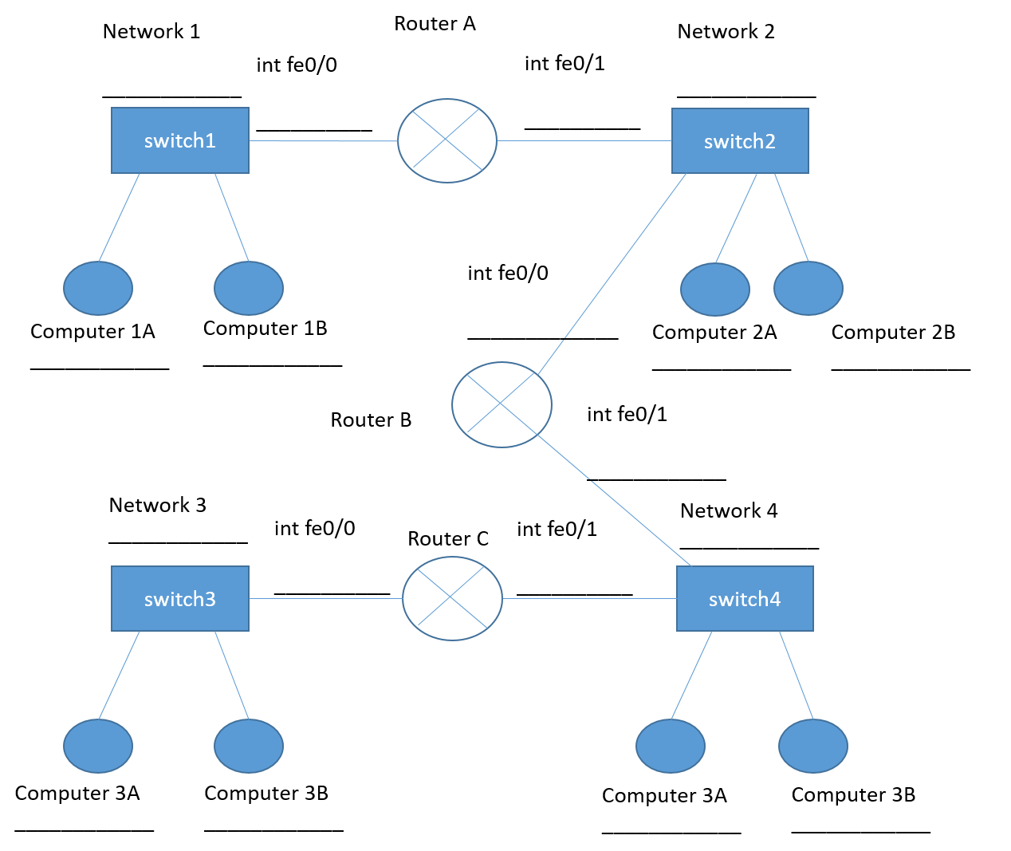

Fill in the default route (really, they are static routes for any address) commands you will use:

Router A:

Router C:

Fill in the static route commands for Router B:

Route to Network 1:

Route to Network 3:

## Simulate the Design

Put your design into Packet Tracer. Make sure that it really works, and all hosts can ping each other.

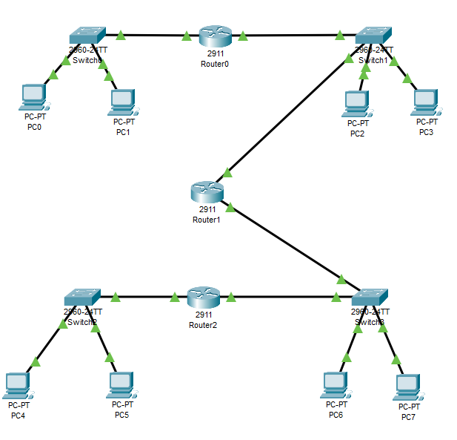

## Design Review

The entire class should agree on a design and present it to the instructor for approval.

## Configure Each Side

Deploy your configuration in small steps. Do no proceed to the next step until the current step works. Configure your computers with IP addresses that match your design and configure the interface IP addresses on your Router (A or C).

1. Can the two workstations on the same side of a router ping each other?
2. Can the two workstations ping the nearest router interface?

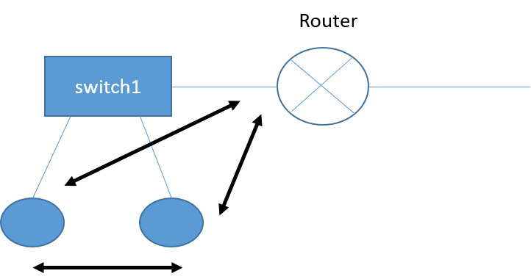

1. Can workstations ping the other side of the nearest router?

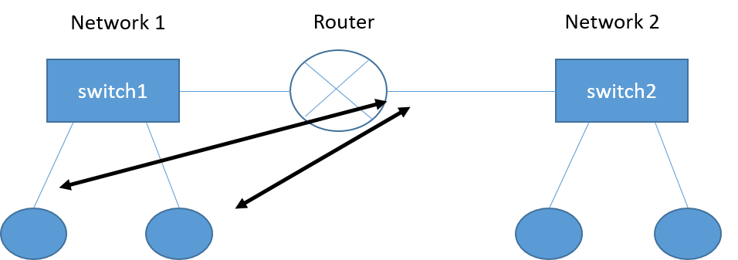

1. Can the workstations on opposite sides of the router ping each other?

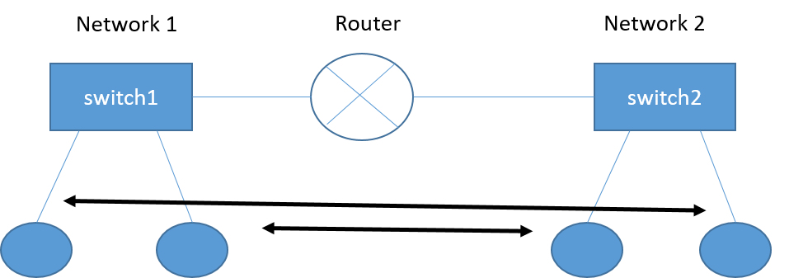

## Join the Two Sides

Connect Router B. Interface fe0/0 should connect to Switch 2 (Network 2) and interface fe0/1 should connect to Switch 4 (Network 4).

Configure IP addresses on Router B’s interfaces, according to your design.

1. Can Router A ping Router B?
2. Can Router B ping Router C?

## Configure the Default/Static Routes

Enter the default routes from your design into Routers A and C.

Enter the static routes for Router C into Router C

## TEST METHODICALLY!!!

If one test fails, do not proceed until you have the problem fixed.

We’ll use Computer 1B as an example, although the same ping tests could be done from Router A or Router C. You should have already shown that Computer 1B can ping both sides of its own router, as well as the computers on Network 2.

1. Can 1B ping the nearest interface of Router B? If not, there may be errors in either Router A’s default route or Router B’s static route to Network 1.
2. Can 1B ping the other interface on Router B?
3. Can 1B ping a computer on Network 4? If not, there may be problems in Router B or in the default gateway of the host on network 4.
4. Can 1B ping the closest side of Router C?
5. Can 1B ping the other interface on Router C? Problems with Router B or C’s table could cause this to fail.
6. Can 1B ping a computer on Network 3? Routers A, B, and C all have to be correct, as well as the host on Network 3’ IP address, mask and default gateway, for this to work.

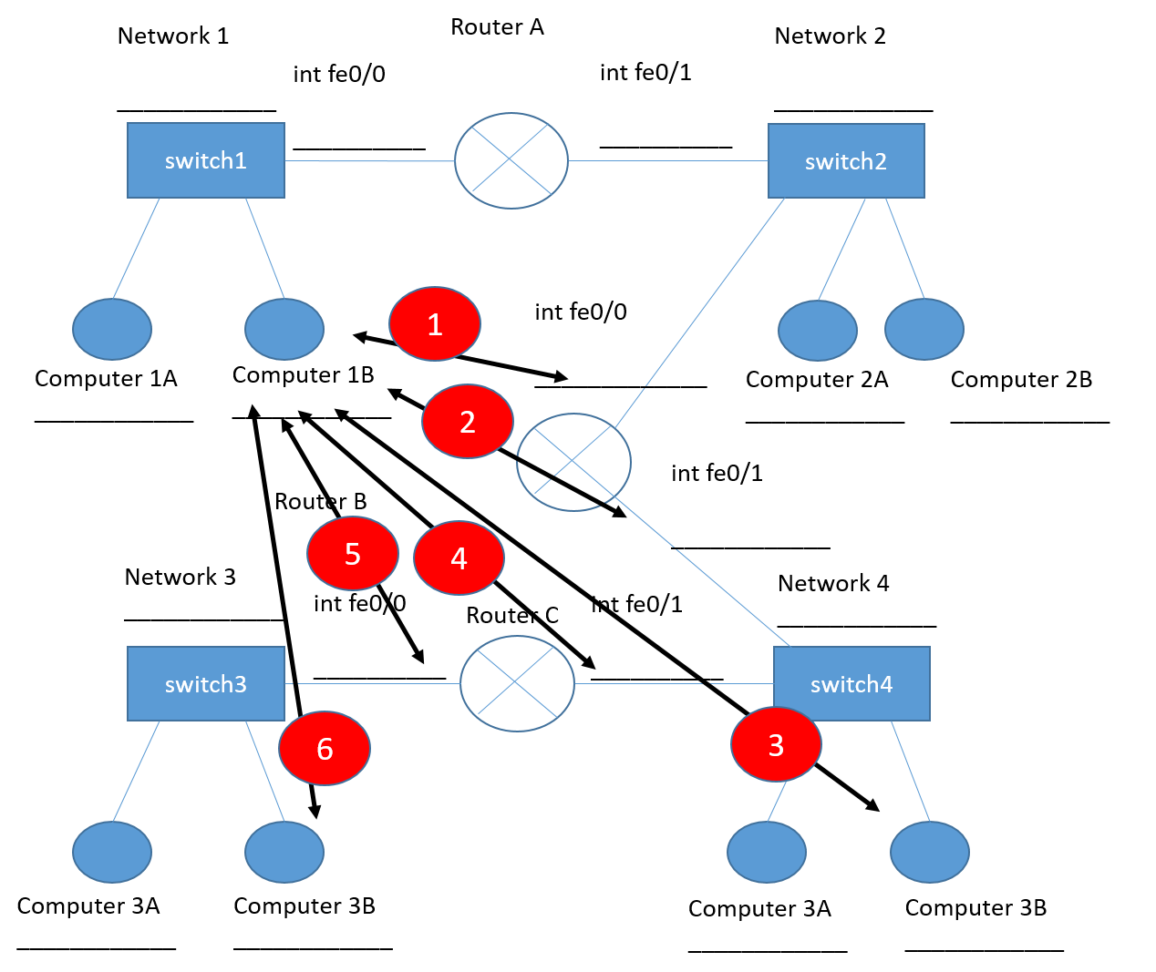

# Hand In

One person in the class needs to hand in the completed design document. Each person in the class should hand in copies of the route tables for Routers A, B, and C. (The command is *show ip route* )

# Routing Protocol--RIPv2

You can probably see by now that manually entering static routes in every router could be a pain, especially if you have many routers. Routing protocols allow routers to communicate with each other to determine their routes automatically. We will use a very simple routing protocol, RIP v2 (Routing Information Protocol version 2.) RIP is not often used in practice, but it is simple to configure and good enough for our lab. (Routing protocols are judged and chosen based on three main factors. Reliability is important; it is bad when links go up and down because of protocol problems. The quality of routes the protocol selects is important; a path that takes three hops over 10 Gbps links is better than one that takes one hop over 100 Mbps, for example. Lastly, the protocol should select a new solution (converge) very quickly when router connections change.)

## Remove Static Routes

Remove all static and default routes from the routers. To remove a command, simply put “no” in front of the command.

*no ip route 192.168.3.0 255.255.255.0 192.168.4.1*

Verify that all the routes are gone by entering the router command, *show ip route*. All the static routes you entered in the static portion of the lab should be gone, and only direct connections remain.

## Configure RIPv2

The router commands for RIP are simple. To tell the router you want to use RIP, enter *router rip*. Then tell it to use version 2; *version 2.* Lastly, tell the router which routes that it is directly connected to that it should send to the other routers (advertise). In our case, we want our routers to advertise all the direct connections.

**Router A***router rip  
 version 2  
 network 192.168.1.0  
 network 192.168.2.0*  
**Router B***router rip  
 version 2  
 network 192.168.2.0  
 network 192.168.4.0*

**Router C***router rip  
 version 2  
 network 192.168.3.0  
 network 192.168.4.0*

## Test

On each router, use show ip route to verify that the router knows about all four networks. Test pings between the routers and hosts to ensure that all hosts have connectivity.

# Restore the lab to its normal configuration